**Team Name**: We Can Do It

**Date of Submission:** 10/08/2021

**Meeting Date & Time:** 10/06/2021 @ 6:00PM

**Meeting Location:** Zoom

**Meeting Duration:** 48 minutes

| **Team Members** | **X = Present** | **Notes** |
| --- | --- | --- |
| Dhari Alenezi | X |  |
| Abdulrahman Alharbi | X |  |
| Elina Do | X |  |
| Andrew Nguyen | X |  |

**Progress:**

**Team accomplishments for the week:**

This week, our team met with Mr. Stallard and the TAs for a review. We gathered our materials and presented our work. We also started reaching out to teams for our Technical Peer Reviews. We have contacted the WPD and will be meeting with them this week to show our application and receive feedback. We also recorded a video of the prototype of the mobile application, and we shared it with the WPD.

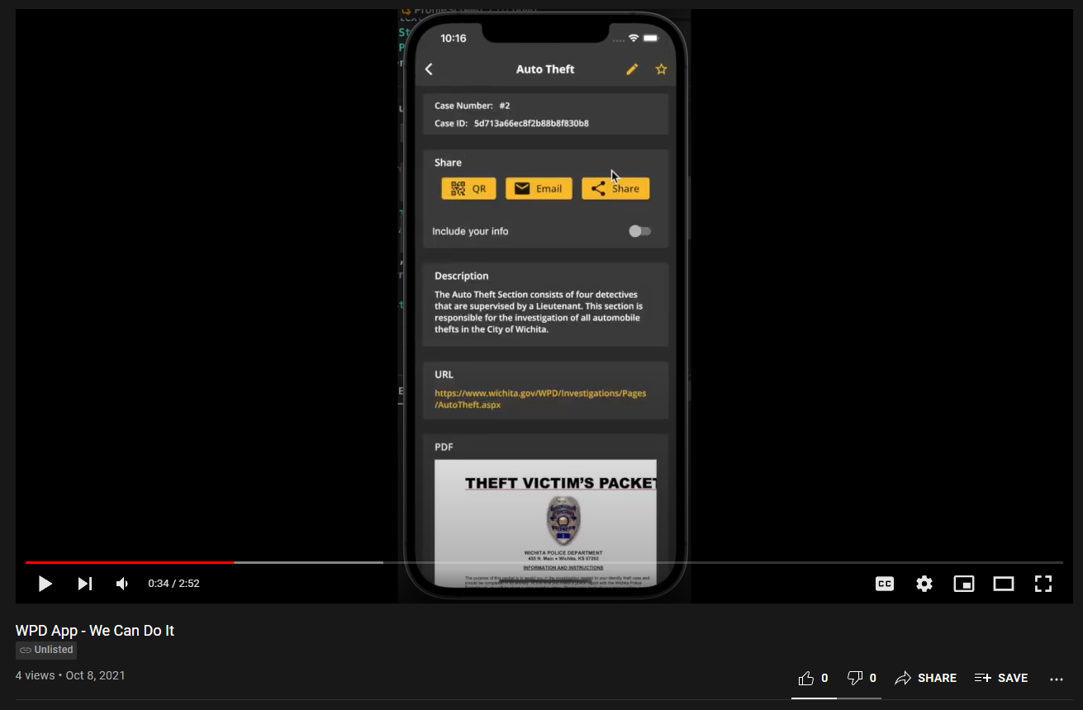

<https://youtu.be/U9I3dyisejw>

**Individual contributions:**

**Dhari Alenezi:** This week I developed the single case screen, and added three ways to share the case with other people by using QR code, Email, and Share button. I used the flutter_pdfview package to preview the pdf files. Also, I developed the control panel, so that the admin user can create and remove accounts.

**Abdulrahman Alharbi:** I have worked on preparing for the presentation. By reviewing the prototype for the app and gathering the wireframe designs for the app. I am also looking into how to create a user guide manual. So, it can help me with creating one for the App.

**Elina Do:** I made an ER diagram to help determine and finalize the fields for our models and figure out what other models we want. I also added sample cases from the WPD website into our data for testing. I have been contacting the WPD and set up a time for us to meet with them next week and show them our work.

**Andrew Nguyen:** Finished coding site to grab data from http point and displaying it on page. Finalizing site to be able to handle users entering in ID on to url or case number on page and displaying it dynamically.

**Project Tracking:**

| **Team Member** | **Assignment** | **Due Date** | **% Complete** |
| --- | --- | --- | --- |
| Dhari Alenezi | Developing the QR logic & Case screen | 10/09/2021 | 90% |
| Dhari Alenezi | Developing the faviorte screen | 10/14/2021 | 20% |
| Abdulrahman Alharbi | Working on the front end of the app | 10/18/2021 | 20% |
| Elina Do | Complete first draft of base code for database in MongoDB | 09/17/2021 | 50% |
| Andrew Nguyen | Create static web prototype for WPD to test and give feedback on | 09/19/2021 | 100% |
| Andrew Nguyen | Link web app with back end to display information | 10/06/2021 | 30% |
| Andrew Nguyen | Fix some minor issues with static web prototype | 09/30/2021 | 80% |

**Plan:**

| **Assignment** | **Due Date** |
| --- | --- |
| Finish developing and structuring the HTTP endpoints | 10/9/2021 |
| Developing the QR logic | 10/09/2021 |
| Developing the faviorte screen | 10/14/2021 |
| Link the HTTP endpoints with the mobile application | 10/17/2021 |
| Support web application | 10/20/2021 |
| Try & test NFC technology (Near-field communication) | 10/30/2021 |
| Developing the cache feature for the mobile app | 10/31/2021 |
| Testing both the frontend & backend sides | 11/7/2021 |
| Web App final review | 11/14/2021 |
| Web App finalized and ready for presentation | 11/28/2021 |
|  |  |
|  |  |
|  |  |
|  |  |
|  |  |

**Issues:**

Include the schedule for the next meeting:

Meeting Date & Time: 10/14/2021 @ 6:00PM

Meeting Location: **Zoom**